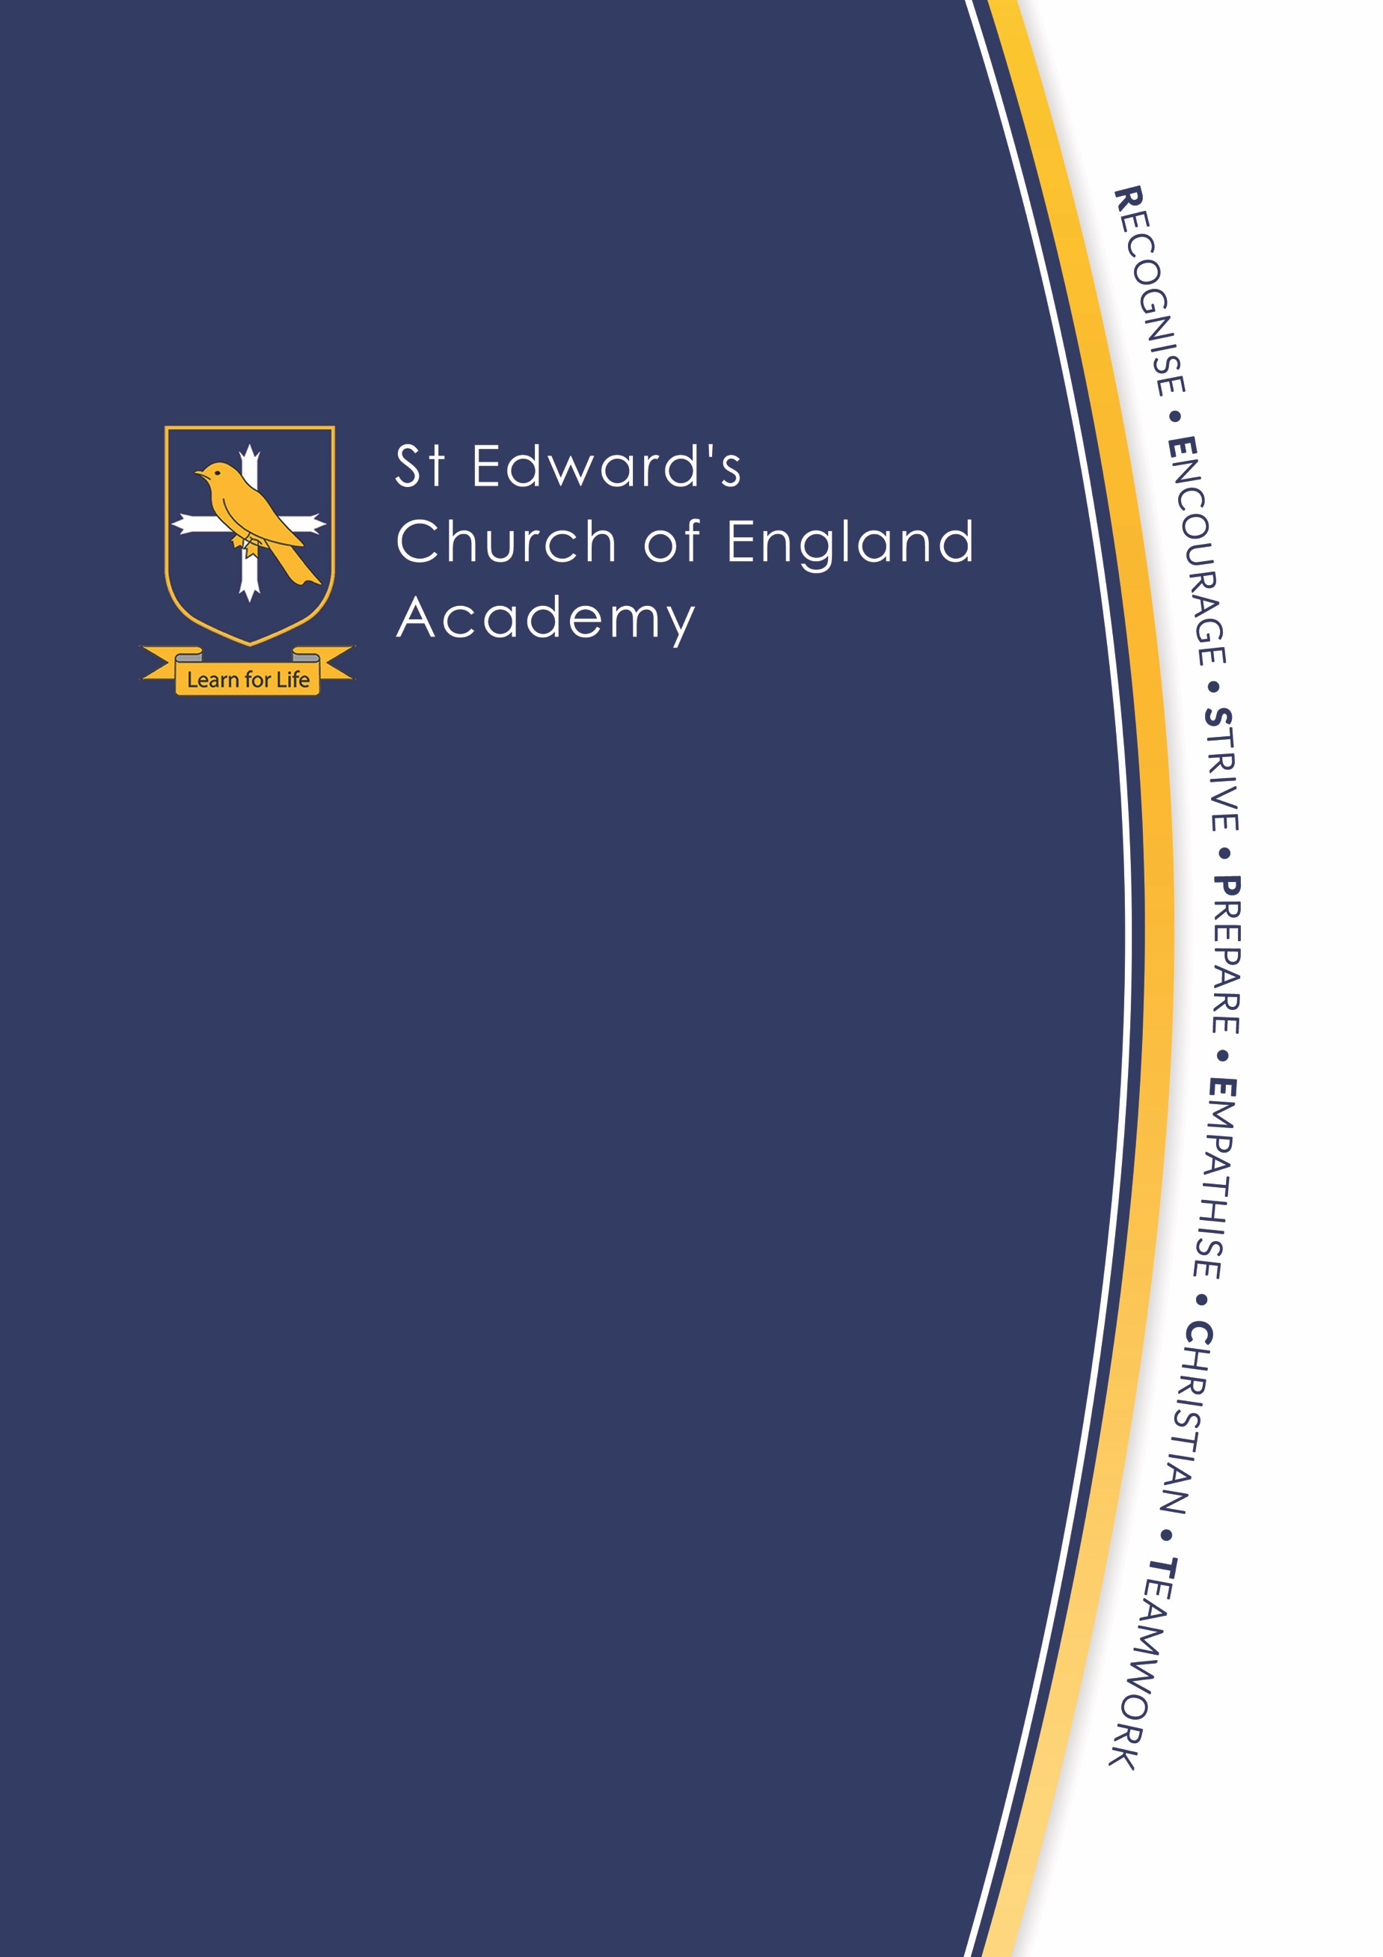

Pupil Information Collection Pack

Child’s Name:

Please return this pack to the office at St Edward’s Church of England Academy

Table of Contents

The Vision for Education within a Church of England Academy 3

St. Edward’s Church of England Academy Vision, Ethos and Values 4

We are a 10:10 School! 4

Pupil Information Sheet 5

Section 1 - Pupil Details 5
Section 2 - Pupil Arrangements 5
Section 3 - Parent/Guardian Information 5
Section 4 - Emergency Contact 6
Section 5 - Medical Information 6
Section 6 - Pupil Reports/Parents’ Evening 6
Section 7 - General information 7
Section 8 - GDPR 7

Emergency Closure 8

Home School Agreement 9

Internet Permission Form 10

Permission Forms 11

Photography and Video Consent 11
Education Trips and Visits 11

Medical Information Form 12

Friendship and Interests Sheet 13

Biometric Consent Form 14

The Vision for Education at our Academy
Jesus says, "I have come that they may have life and have it in all its fullness."
John 10:10

Our school vision is to ensure that God’s aspiration for us all, as expressed in Jesus’s words from John 10:10, is reflected in our aspiration for all of our children and staff to experience a full and rich life of learning, growing, helping, and caring for each other.

We are an inclusive community where all are welcomed, supported and celebrated for all they are and for all they do. Our Academy is a place of, and a space for, flourishing and fulfilment because here…

…we are 10:10 people.

As a Christian Academy, we live and breathe our core values:
- Respect
- Courage
- Hope
- Friendship
“For I know the plans I have for you, declares the Lord, plans to prosper you and not to harm you, plans to give you hope and a future.”
Jeremiah 29:11

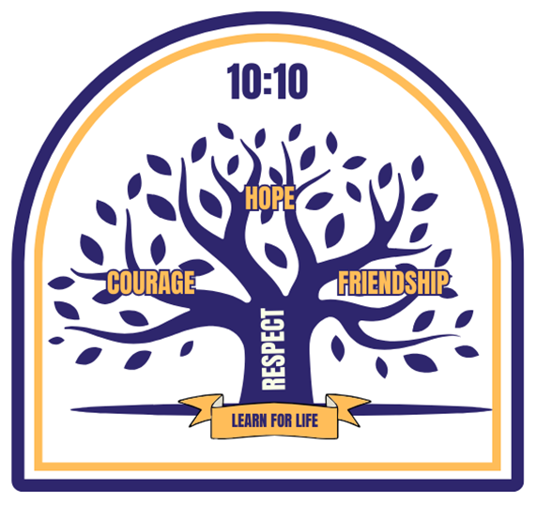
“Be strong and courageous. Do not
be afraid; do not be discouraged for
the Lord your God will be with you wherever you go.”
Deuteronomy 31:6
“I no longer call you Followers. Instead I call you friends.”
John 15:15

“Show proper respect to everyone”
1 Peter 2:17

PUPIL INFORMATION SHEET (*please delete as necessary/please tick one answer for each question )

Section 1 - Pupil Details
It is important for data accuracy that all questions are completed. It may seem that there are duplications but forms are divided upon return.
Pupil Legal Surname: |  |  |  | Pupil Preferred Surname (if different):
If legal name differs from birth certificate please attach copy of relevant documents
Pupil Legal Forename: | . |  |  | Pupil Preferred Forename (if different):
Date of Birth: | Day | Month | Year | Is your child a twin/triplet? Yes No
Sex: | Male Female |  |  | If Yes, would you like them placed together? Yes No
Gender Identity |  |  |  | Pronoun(s)
Current Address: |  |  |  | Home Telephone:
Post Code: |  |  |  | Current School:
Does your child have any siblings at St. Edward’s? Yes No |  |  |  | If Yes, what is their name and tutor group?

Section 2 - Pupil Arrangements
Does your child live with both parents who are named on the child’s birth certificate? | Yes No  If Yes, move to Section 3. If No, please complete the following:
Please state what residency arrangements are in place for your child:
Court Orders/Certificates  Are there Court Orders in place regarding contact? | Yes No Please attach a copy of the Order
Is your child in foster care? | Yes No
Is your child adopted? | Yes No Please attach a copy of the Certificate
You do not have to give adoption information but it may be possible to obtain extra money towards your child’s education.
Is there a Residence Order in place? | Yes No Please attach a copy of the Order
Is your child a young carer? | Yes No

Section 3 - Parent/Guardian Information
Mother’s (or guardian’s) full name: | Miss/Mrs/Ms/Dr*
Mother has parental responsibility: Yes No | Mother is at same residential address as child: Yes No
If different, please give address:

Email address:
** Important as all correspondence is emailed

Father’s (or guardian’s) full name: | Mr/Dr*
Father has parental responsibility: Yes No | Father is at same residential address as child: Yes No
If different, please give address:

Email address:
** Important as all correspondence is emailed

Does anyone else hold legal parental responsibility for your child? | Yes No Please attach a copy of the Court Order
If Yes, please provide details including name and address:
Section 4 - Emergency Contact
1st  This person will be contacted first in the case of an emergency or if your child is ill | Full Name: | Mobile Telephone:
 | Email: | Home Telephone:
 | Relationship to the Child:  Note: First contact must have parental responsibility. Texts and emails from the Academy will be sent to this person. | Work Telephone:
2nd  This person will be contacted second in the case of an emergency or if your child is ill | Full Name: | Mobile Telephone:
 | Email: | Home Telephone:
 | Relationship to the Child:  If you have parental responsibility, would you like to receive texts and emails from the Academy? Yes No | Work Telephone:
3rd  This person will be contacted third in the case of an emergency or if your child is ill | Full Name: | Mobile Telephone:
 | Email: | Home Telephone:
 | Relationship to the Child:  If you have parental responsibility, would you like to receive texts and emails from the Academy? Yes No | Work Telephone:

Section 5 - Medical Information

Does your child have any medical conditions? Yes No | If Yes, please give details on the medical form on page 12 of this booklet.

Section 6 - Pupil Reports/Parents’ Evening

If a second copy of report/parents’ evening information is required for a non-resident parent, please provide an email address (important as all correspondence is emailed). If the non-resident parent has parental responsibility, it is their legal right to receive this information:
Name: |  | Relationship to Pupil:
Email address: |  | Please re-confirm if this person has parental responsibility:  Yes No
Note:
Not all parents have parental responsibility and it can be difficult to understand your rights if you don’t live with your child. Similarly, it can be hard, if you are a parent who has a child living with you, to understand what rights and responsibilities that you and the other parent may have.
To clarify:
- Mothers and married fathers automatically have parental responsibility.
- Fathers who were never married to the child’s mother might not have parental responsibility depending on when the child was born and whether their name is on their birth certificate.
- You can get parental responsibility in a number of ways such as if you adopt a child or the court makes a residence order in your favour. If you are an unmarried father and the mother agrees to you having parental responsibility, it can be quick and relatively easy to obtain. If no agreement about who should have parental responsibility can be reached, you might need to obtain a court order. In some rare circumstances such as when a child is adopted, parental responsibility can end. The law is clear that if you had parental responsibility before you separated, your responsibilities continue whether a child lives with you or not after the break up. In fact, the law encourages resident and non-resident parents to work together for the best interests of their child.

Section 7 – General Information
This information is required by the Department for Education as part of the Academy’s Census return.
Place of Birth: ________________________________________________ Nationality: ________________________________________________

Proficiency in English (please tick):
- New to English Yes No
- Early acquisition Yes No
- Developing competence Yes No
- Fluent Yes No
Ethnicity: ____________________________________________________ Primary Language (if not English): _____________________________
Religion: ____________________________________________________ Has your child been baptised (christened)? Yes No
Is either parent serving in the Armed Forces? Yes No

Is your child in the care of the local authority? Yes No If Yes, which authority: __________________________________________

Does your child receive free school meals? Yes No
(If No, and you feel you may be eligible for free school meals, please contact Staffordshire County Council through their website: www.staffordshire.gov.uk/Education/Educational-awards-benefits/FreeSchoolMeals/Apply-online.aspx

Does your child have an Education Heath and Care Plan (EHCP)? Yes No If Yes, which authority: __________________________

Does your child receive any SEND support at present? Yes No If Yes, please give further information in the box below.

Please provide any information that you think may help us to help your child:

Section 8 - The General Data Protection Regulations (GDPR)

Due to GDPR, you MUST tick the following boxes for data to be held on our records:
It is the responsibility of the parent/guardian to make sure permission has been given by the named emergency contacts for St Edward’s Academy to hold their personal data.
- You give consent for us to hold the personal data provided on our Academy systems during your child’s education at the Academy.
- Consent has been given by any family member/relative for us to hold the personal data provided (e.g. their contact details) on our Academy systems during your child’s education at the Academy.

EMERGENCY CLOSURE

Pupil’s Name:

In the event of an Emergency Closure, information is communicated via text message. Please confirm the name and mobile number of the 1st priority parent/guardian for text messages to be sent to:
Name of 1st priority parent/guardian: |  | Mobile number:

In the event of an Emergency Closure – please tick one option only:

 | A | My child will walk home to the following safe address.  This can be your home address. Please write it in the box below.
 |  | Safe address:
 |  | This address is my child’s normal home address: Yes No
 |  | If No, whose address is this?

 | B | My child will go home by bus to the following safe address.  This can be your home address. Please write it in the box below.
 |  | Bus number:
 |  | Safe address:
 |  | This address is my child’s normal home address: Yes No
 |  | If No, whose address is this?

 | C | My child is not to leave school until I collect him/her from school.

If your child is travelling home/being collected from school with a sibling, please confirm below:
Sibling’s name: |  | Tutor group:

Note: it is the responsibility of parents/guardians to update the school if any details change.

In the event of an Emergency Closure, the above information will be strictly adhered to. Please see our Emergency Closure Procedure in the Parents Section on the school website.

HOME SCHOOL AGREEMENT
Academy Vision: Allowing all to live life in all its fullness | Our Academy Values | As an Academy,  we will | As a Parent,  I will | As a Pupil,  I will
 | Recognise  Article 28 Every child has the right to education  Article 24 Every child has the right to the best possible health  (Genesis 1:27) | Provide a varied curriculum with RE at the centre.  Enable all to flourish and so enjoy life to the full by providing a safe and caring place.  Provide high quality PE, Personal Social Health Education, free school meals, and extra-curricular opportunities.  Protect pupils’ right to privacy and ensure pupils understand how to keep themselves safe online. | Support the Academy’s policies for discipline and behaviour.  Attend Parents’ Evening and read letters sent home.  Support and inspire my child. | Be sensible, polite and considerate to others.  Tell an adult if something is worrying me or something important happens.  Be inspired and think about my future.
 | Encourage  Article 3 The best interests of the child must be the top priority in all things affecting them  (1 Peter 4:10) | Work closely with parents and guardians as partners in our learning community.  Encourage all to lead, learn and live life in all its fullness. | Make sure the Academy is kept fully informed of anything that might affect my child’s work, behaviour or attendance. | Suggest, take part in and lead activities.  Be an advocate for change.
 | Strive  Article 29 Education must develop every child’s personality, talents and abilities to the full  (Philippians 4:13) | Set targets to challenge all to strive to do more and achieve more in order to be more.  Provide support for future pathways in education and work.  Monitor attendance and punctuality.  Provide support with attendance issues. | Ensure that my child attends school regularly and punctually, fit to work and with the correct uniform and equipment. | Attempt all classwork and homework tasks to the best of my ability.  Attend school regularly.  Behave in a polite and supportive manner.
 | Prepare  Article 5 Children should be directed and guided as they grow up  (Luke 1:37) | Provide opportunities which prepare pupils to become active citizens.  Remove barriers to pupil achievement and celebrate success.  Help pupils prepare for their future by teaching them about careers and higher education. | Talk to my child about what they enjoy at school and encourage them to engage with activities. | Wear the correct uniform and be tidy in appearance.  Bring the correct equipment to school.  Take care with school equipment.
 | Empathise  Article 42 Governments should make the Convention known to children and adults  (Ephesians 4:2) | Make ethical decisions in the leadership of our Academy.  Deliver a curriculum within a framework of the Rights Respecting Schools Award, the International Schools Award and the Global Goals which encourages pupils to empathise with others and become ‘global citizens’.  Challenge stereotypes and celebrate our diverse talents. | Respect my own child’s rights and the rights of other children and their families.  Embrace diversity and equality for all. | Treat everyone with respect.  Be a courageous advocate for change.
 | Christian  Article 14 Every child has the right to freedom of thought, belief and religion  (John 3:16) | Provide pupils with the opportunity to explore and challenge our own and others’ viewpoints of the Church.  Examine different faiths, backgrounds and outlooks on life.  Teach powerful social action to every pupil. | Encourage my child to discuss their beliefs and those of others with respect. | Share opinions respectfully and listen to the opinions of others.  Celebrate and respect diversity and equality.
 | Teamwork  Article 31 Every child has the right to relax, play and take part in a wide range of cultural and artistic activities  Article 12 Every child has the right to have a say in all matters affecting them  (Romans 12: 4-8) | Provide opportunities for pupils to work with each other in a range of settings: PE, fieldwork, music and drama.  Promote teamwork to develop a better understanding of who we are and our responsibilities to others.  Listen to the views of pupils and encourage them to take an active role in Academy life: School Council, 10:10 Ambassadors and Antibullying Ambassadors.  Campaign to ensure the world God created is safe and protected. | Support my child and encourage them to take part in extra-curricular activities. | Take part in team activities, work with other pupils and treat others with respect, dignity and equality.
The Articles above relate to the Articles of the United Nations Convention on the Rights of the Child.
Signed (Parent/Guardian): | Date:

Signed (Pupil): | Date:

INTERNET PERMISSION FORM

Pupil’s Name:
My parents/guardians and I have read and discussed the ‘Rules for Responsible Use of the Internet’ and I agree to follow them.
Signed (Pupil): |  |  | Date:

Rules for Responsible Use of the Internet

I will ask permission from a member of staff before using the internet and I will not use the internet if a member of staff is not present.

I will use only my own login and password for the school network and Learning Platform which I will keep secret. This means that I will not share this information with anyone, not even a close friend.

I will not access other people's files and work areas.

I understand that the school reserves the right to delete any files that may be held on the school network or Learning Platform.

I will use the computers only for school work and homework.

I will not bring USB sticks or other storage media into school.

I will not damage hardware or intentionally waste resources e.g. printing pointlessly.

I will only use email when given permission to do so and I will only email people I know, or my teacher has approved.

The messages I send will be polite and sensible. Any use of email and other electronic media to bully or hurt others will lead to contact with your parents/guardians and may involve incidents being reported to agencies such as the police.

I will not upload photographs or give my home address, phone number or other personal details of myself or other people or arrange to meet someone.

I will not use websites or software that bypasses the school’s e-safety and internet filtering systems.

I know that my usage of ICT, including email and web browsing, can be checked and logged and that my parent/guardian will be contacted if a member of school staff is concerned about my e-safety or my ICT activities.

I understand that these rules are designed to keep me safe and that if they are not followed, school sanctions will be applied and my parent/guardian may be contacted.

Please note: Anyone not following the ‘Rules for Responsible Use of the Internet’ will have their access denied for a period of time and their parent/guardian will be informed.

PERMISSION FORMS

Photography and Video Consent

At St Edward’s Academy we like to celebrate the successes and achievement of our pupils by taking photographs and videos to appear on displays in corridors and in classrooms, on the Academy website, on the Academy social media channels, and in key Academy publications such as the prospectus and newsletters.

Photographs and video images are classed as personal data. For this reason, we require the consent of the individual concerned or – in the case of pupils – their parent or guardian before we can display images of pupils.

I agree I do not agree to the use of my child’s image as outlined above.

I agree I do not agree to the use of my child’s name as outlined above.

Educational Trips and Visits/P.E. Sporting Activities/Matches/Practices

I give permission for my child to take part in off-site activities/visits organised by the Academy and I understand and accept the following condition (please note that individual notification of each Academy visit/activity will be sent to parents/guardians at the time of the visit/activity).

I agree that medical and dental treatment may be given to my son/daughter if necessary, including the administration of a general anesthetic and to surgical operations in the case of emergency, in accordance with the recommendation of a qualified practitioner.

I acknowledge that my child’s behaviour may be taken into account when organising trips.

SIGNATURE OF PARENT/GUARDIAN COMPLETING THIS PUPIL INFORMATION COLLECTION PACK

Signature of Parent/Guardian: |  | Relationship to Child:
Name of Parent/Guardian: |  | Date:

MEDICAL INFORMATION FORM

Pupil’s Name:
Doctor’s Name:
Medical Practice:
Address:
Telephone Number:

Dietary requirements:
Please provide further information

Does your child have any medical conditions? Yes No
Please provide further information and include conditions such as irritable bowel, where your child may need a toilet pass

Is your child currently on a medical care plan? Yes No
Please provide further information

Does your child have any allergies? Yes No
Please provide further information

Does your child require an adrenaline pen for anaphylaxis (allergies)? Yes No
Please provide further information

Does your child have asthma? Yes No

Is your child currently receiving a prescription for an inhaler from your doctor, but has not yet been diagnosed with asthma?
Yes No

Does your child take any regular medication? Yes No

If Yes, what is the name of the medication? ________________________________________________
Where is it taken? Home School
Please provide further information

Is there is any other additional medical information we may require regarding your child?
Please provide further information and continue on a separate sheet if needed

Asthma inhalers and adrenalin pens need to be sent to the school office and a spare kept in your child’s bag. All other medication to be handed in at the school office. Owing to our Supporting Pupils with Medical Conditions Policy, please send medication in the original packaging with medication instructions which have been prescribed by your doctor.
FRIENDSHIP AND INTERESTS SHEET

Pupil’s Name:

Current school:
Name of any siblings and their tutor group at St Edward’s:
Parent/guardian’s daytime contact telephone number:

Please provide the first name, surname and school (if not the same school as your child) of any pupils your child would prefer to be grouped with up to a maximum of 6 pupils. We will do our very best to ensure that your child is in a tutor group with at least one of their friends. Although this cannot be guaranteed, it is much more likely to happen where more names are given.
1 | 4
2 | 5
3 | 6

Is your child involved in any sport in school? Yes No
If yes, please give details:

Is your child involved in any sport outside school? Yes No
If yes, please give details:

Is your child involved in any other activities inside or outside of school which you would like us to know about? Yes No
e.g. Brownies, Beavers, church youth club, chess club, etc. - please give details:

Is your child involved in a music group/choir? (in or out of school) Yes No
If yes, please give details:

Does your child have music tuition in or out of school? Yes No
If yes, please give details:

If there is anything else you would like to tell us about your child, which may be helpful to us when organising tutor groups, please let us know in the box below:

Office Use Only
Feeder Siblings Twins Medical SEND EHCP PP Sport Music Tutor Group ___________
CONSENT FORM FOR THE USE OF BIOMETRIC INFORMATION IN SCHOOL

Prior to signing this consent form, please refer to the separate Biostore Cashless Catering information provided.

Please complete this form if you consent to your child using biometric systems during their education at St Edward’s Church of England Academy.

Once your child ceases to use the biometric recognition system, his/her biometric information will be securely and permanently deleted by the school.

I give consent to St Edward’s Church of England Academy for the biometrics of my child to be used as part of a recognition system as described above and in the separate information provided. I understand that I can withdraw this consent at any time in writing.
Pupil’s Name:
Pupil’s Tutor Group  (if known): | Please leave blank if not known
Name of Parent/Guardian:
Signature of Parent/Guardian:
Date:

