Quick Search in Accelerated Reader Bookfinder
Quick Search allows you to use keywords to search for matching book and article titles, authors or topics.
- Select Quick Search.
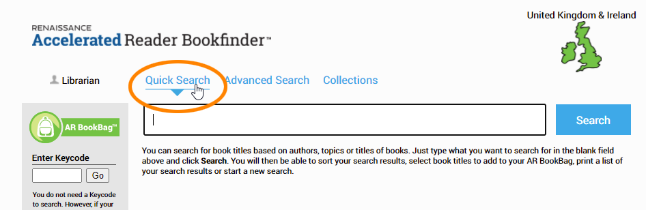
- Type a book title, author's name, keyword or topic into the blank field.
  - Topics are categories assigned by Renaissance Learning. You can view topics from either the Advanced Search page or on the left side of a page with search results, under Topic.
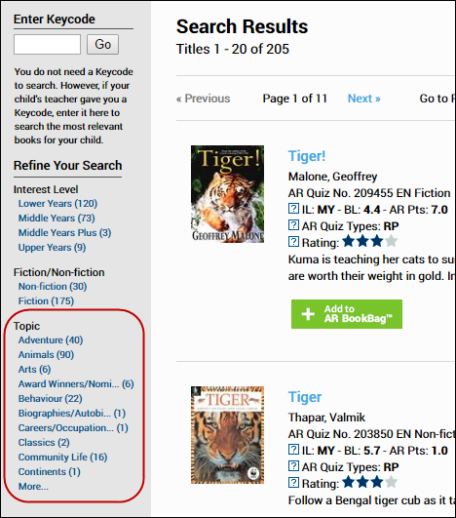
- Select Search.
- The Search Results page will open.

