Not sure what to read next?
Rmember the aim of Accelerated Reader is to move up your ZPD range as quick as you can.
In order for tickets to be counted your book MUST be in your ZPD range.
You can read books ABOVE your range.

So, not sure what to read next?
Think of a book you really enjoyed
Using Google search type in ‘Books similar to…’
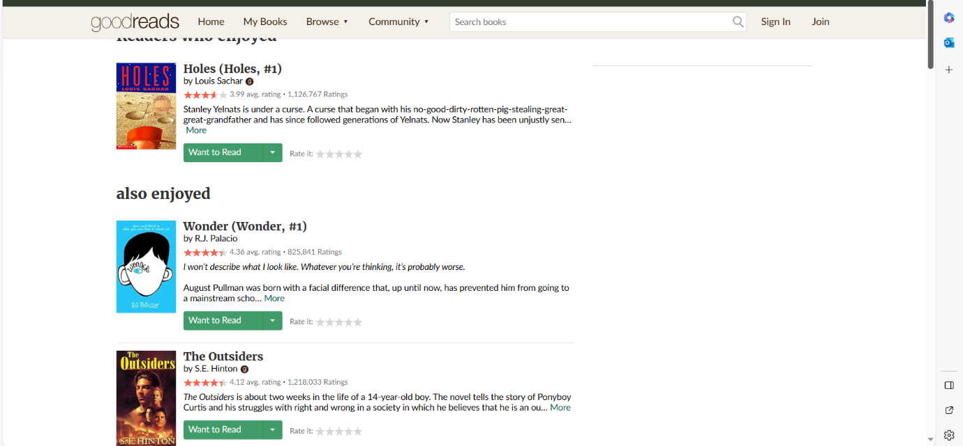
For example: ‘Books similar to Holes.’

The Goodreads website will give you lots of ideas.
Remember to check the ZPD using AR Bookfinder

