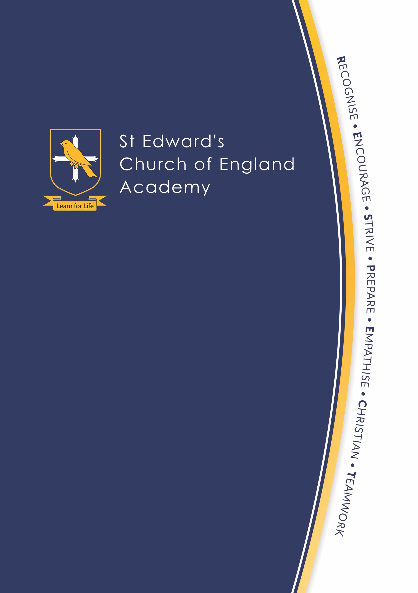

Careers Advice for
Pupils and Parents

Careers education prepares pupils for the world after school. This includes thinking about how to look after themselves as an adult, how to relate to other people and how to fit into society. St Edward’s Church of England Academy provides information, guidance and help with making decisions about the future to all students from Y7 upwards. This includes information on post-16 options including sixth form, college, apprenticeships, training and university study, and entry to a range of jobs and careers. As a parent you want the best for your child and it's never too early to start thinking about their options.

What can pupils and parents expect? The Government set out what pupils and parents should expect in terms of careers advice:

- Every pupil, and their parents, should have access to good-quality information about future study options and labour market opportunities. By the age of 14, all pupils should have accessed and used information about career paths and the labour market to inform their own decisions on study options.
- Parents should be encouraged to access and use information about labour markets and future study options to inform their support to their children.
- Pupils should be provided with reliable information about the local and national labour market as this is vital to inform good-quality information about jobs and career paths.
- By the age of 14, every pupil should have had the opportunity to learn how the different STEM (Science, Technology, Engineering, Maths) subjects help people to gain entry to, and be more effective workers within, a wide range of careers.
- Every pupil should have multiple opportunities to learn from employers about work, employment and the skills that are valued in the workplace. This can be through a range of enrichment activities including visiting speakers, mentoring and enterprise schemes.
- Every year, from the age of 11, pupils should participate in at least one meaningful encounter with an employer.
- All pupils should understand the full range of learning opportunities that are available to them. This includes both academic and vocational routes and learning in schools, colleges, universities and in the workplace.
- By the age of 16, every pupil should have had a meaningful encounter with providers of the full range of learning opportunities, including sixth forms, colleges, universities and apprenticeship providers. This should include the opportunity to meet both staff and pupils.

How do we provide pupils with information about course choices and careers?

The Academy’s Careers Policy sets out our commitment to delivering high quality careers advice for all pupils.

Pupils regularly have the opportunity to learn from local colleges, universities and employers. This may be through a workshop session, a lesson or a school trip. Many visits are STEM (Science, Technology, Engineering and Maths) related such as local employers visiting lessons or chemistry masterclasses at Keele University.

St Edward’s Academy works in liaison with Stoke-on-Trent and Staffordshire LEP and The Careers and Enterprise Company to ensure high quality careers provision for all pupils as set out by the ‘Gatsby Benchmarks’

All Key Stage 3 pupils receive the following three strands of careers education and guidance:

- The curriculum aims to equip students with the knowledge, skills and experiences necessary to succeed in the world of work through range of activities related to economic well-being, taking responsibility, working together and a range of personal skills. During each taught unit, teachers make links between the curriculum topics and the world of work to help pupils understand how their learning can be applied in real life situations
- Alternative curriculum provision offers pupils the opportunity to explore post 16 and career options
- General careers advice and guidance on progression into the world of work is provided by independent advisors via a Y8 careers fair.

All Key Stage 3 pupils
During tutor time, collective worship and Alternative Curriculum days, pupils have the opportunity to discover what options are available to them in Year 9 and beyond. Pupils are encouraged to consider a variety of options based on their interests and skills.

Skills Fair (Autumn Term Year 8) Visit to the ‘World Skills UK Live’ show at the NEC. Pupils have a go at something they’ve never done before by trying hands-on job-related skills across a huge range of careers: TV production, demolition simulation, virtual welding, floristry and 3D modelling and more!

Enterprise Challenge (Spring Term Year 8) A “Dragon’s Den” style activity where teams of pupils compete to develop a product and business plan. Pupils develop their employability skills through team work, learn what employers are looking for and experience writing a CV.

University workshops (Summer Term Y8) provided by Staffordshire University. Team building challenges and activities that develop pupils’ understanding of life at University.

Careers Fair (Summer Term Year 8) Local employers, colleges and apprenticeship providers deliver 30 minute sessions to pupils to explain the role, hours and wages and necessary qualifications for various jobs. Past providers have included: Leek and Buxton College, Ornua Foods, local banks, representatives from the NHS, legal, hospitality and manufacturing industries.

Useful resources for parents and pupils

Comprehensive information links to websites on the academy website https://www.stedwards.academy/parents-and-carers/careers-advice

Where will the jobs be?

To compare jobs, salary http://www.lmiforall.org.uk/explore_lmi/

Labour market advice from Staffordshire County Council

https://www.staffordshire.gov.uk/education/Learning-options-and-careers/Learning-Options-and-Careers.aspx

The National Careers Service provides information on more than 800 jobs, qualifications, pay and future prospects. The Skills Health Check is a set of quizzes and activities designed to help pupils explore their skills, interests and motivations. Working through the Skills Health Check can help them decide what kind of jobs might be right for them.
https://nationalcareersservice.direct.gov.uk/

STEM Careers http://www.wherestemcantakeyou.co.uk/ is a digital toolkit for pupils and teachers. It helps to make the link between the Science, Technology, Engineering and Maths subjects people study in school, college or university and the world of work. Its goal is to bring alive the huge range of opportunities which are open to anyone who pursues STEM subjects.

For advice on University courses, funding and the application process www.ucas.com

Apprenticeships - a genuine job, with training, meaning you can earn while you learn and gain a nationally recognised qualification. Apprenticeships are now available up to degree level and beyond. Over 50 national universities are currently offering a range of degree apprenticeships with more to be confirmed throughout the year.
– Earning a salary and paid holiday
– Excellent progression opportunities, whether looking to study further or climb the ranks within the workplace
– Increased future earning potential– apprentices enjoy marked salary increases on finishing their training and those completing a higher apprenticeship could see increased earnings of an estimated £150,000 over their lifetime

A Parent’s Guide to Apprenticeships

https://assets.publishing.service.gov.uk/government/uploads/system/uploads/attachment_data/file/662464/Parent-Guide-Apprenticeships.pdf

https://amazingapprenticeships.com/ provides resources, information and case studies.

Government guide to apprenticeships https://www.gov.uk/apprenticeships-guide
To search for apprenticeship options https://www.findapprenticeship.service.gov.uk/apprenticeshipsearch

Appendix 1 Meeting the ‘Gatsby Benchmarks’ 2020

 | Curriculum GB4 | Employer Encounters GB5 | Experience of workplace GB6 | Pathways GB7
 | (Links to curriculum) | (In school visits) | (Out of school visits to places of work) | (FE HE Westwood  Apprenticeships)
Year 5 | - Careers session linked to jobs and budgeting (Nov)  - ‘I could’ skills and qualities linked to careers (Jan) | - PCSOs (Jan)
Year 6 | - ‘I could’ skills and qualities linked to careers (March) | - Safe and Sound – Staffs Fire Service (Nov)  - Money matters – Natwest (March)  - PCSOs (March) | - Carsington Water (Oct)  - Leek Fire Station (Nov)
Year 7 | - Jobs sectors (Geog – Nov)  - End of ½ term review of career and link to curriculum in English, maths and science  - ‘I could’ skills and qualities linked to careers (Nov) | - PCSOs (Nov) | - Geog – field trip visit to Ashbourne – survey of jobs sectors
Year 8 | - ‘I could’ skills and qualities linked to careers (Nov)  - End of ½ term review of career and link to curriculum in English, maths and science | - PCSOs (Sept)  - Session with trainer from Sea Cadets (Dec)  - Enterprise Challenge Day (March)  - Speed networking session (May) | - BBC Media City visit and tour (Oct)  - Gardening (ongoing) | - Visit and lesson with Westwood College (Ongoing)  - Team Maths Challenge (spring Term)  - Speed networking session (May)  - Staffs University Big Bang (June)

